1. **Cost Estimation and Budgeting**

**1.1 Task Cost Breakdown**

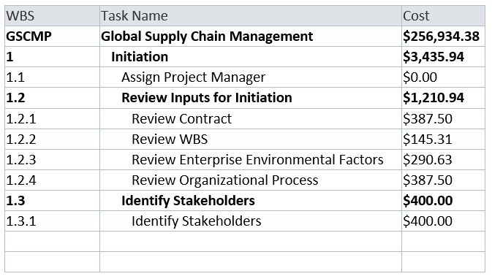

**1.2 Resources Cost Breakdown**

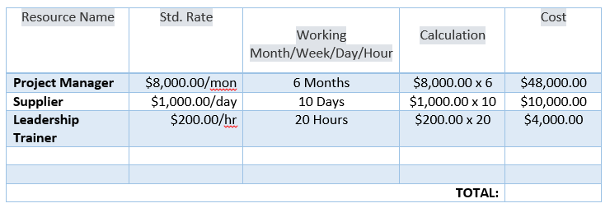

1. **Quality Management Plan**

